APPLICATION OF CONTROLLED VORTEX DESIGN CONCEPT TO AXIAL FLOW INDUSTRIAL FANS

János VAD
Department of Fluid Mechanics, Budapest University of Technology and Economics

Abstract: The paper focuses on the controlled vortex design (CVD) concept applied to design of axial flow turbofans. As addition to the literature discussing the benefits of CVD, a new potential associated with this design technique is presented herein. Namely, CVD allows for customizing the outlet axial velocity profile. As application example, the customized CVD design of a fan of long throw, to be applied in fog cannons, is outlined. Experimental tests on the prototype fan prove the reliability of the product.

Keywords: axial flow fan, jet fan of long throw, controlled vortex design, fog cannon

1. INTRODUCTION
Rotors of axial flow turbomachines are often of controlled vortex design (CVD) [1]. This means that in contrast to the classic free vortex design concept prescribing spanwise constant design blade circulation, the circulation – and thus, the Euler work as well as the isentropic total pressure rise – increases along the dominant part of the rotor blade span in a prescribed manner. CVD guarantees a better utilisation of rotor blade sections at higher radii, i.e. it increases their contribution to the rotor performance. By this means, rotors of high specific performance can be realised, i.e. relatively high flow rate and/or total pressure rise can be obtained even with moderate diameter, blade count, and rotor speed [2-7]. CVD gives a means also for reduction of hub losses by unloading the blade root [5-9], for improvement of static efficiency by reducing the hub diameter [5-6], and offers a potential to avoid highly twisted blades [5-6, 9]. CVD also serves as a conceptual basis for obtainment of fan bladings of simple, easy-to-manufacture geometry [5-6, 10] – even with spanwise (nearly) constant stagger angle and/or chord length. In multistage machinery, CVD provides a strategy to realise an appropriate rotor exit flow angle distribution [1]. By prescription of spanwise increasing blade circulation along the dominant portion of blade span, but moderating the blade circulation near the rotor blade tip, the outlet swirl can be moderated near the circumference. Thus, the stability and coherence of the air jet generated by the jet fan can be improved [11].
References [5-7] provide a thorough overview of the benefits of the CVD technique, with special regard to its application to industrial fans used in air technology. These and other benefits have been published also more recently in references [1-4, 8-11]. As addition to the open literature [1-11], this paper discusses a further potential of this design technique. To the author’s best knowledge, this paper is the first one outlining this potential. Namely, CVD offers a means for tuning the spanwise distribution of outlet flow rate, i.e. for customizing the outlet axial velocity profile. By such means, the axial flow fan can be aerodynamically customized to the particular equipment to be served by it. One example is when the fan serves in automotive coolers, and the engine located close downstream represents a strong blockage effect. As pointed out in [12], the stall and aerodynamic blockage is expected to be pronounced near the hub. Therefore, the near-hub blade sections should be less loaded, and blade sections at higher radii should contribute more to cooling airflow rate. This trend may even more be emphasized when a radial fan applied for cooling of an electric motor, e.g. [13], is replaced by an axial fan for noise reduction and efficiency gain. In this case, it presumably makes no use to expose the motor shield, located close downstream, to cooling airflow at lower radii. Instead, the cooling airflow should probably be intensified rather at higher radii given that the cooling ribs are located at the periphery of the motor.
For another example, axial fans of long throw [2] are taken, applied in “fog cannons” [14-15] used e.g. for fire extinguishment or dust settling, as shown in Figure 1. Such fans must “throw” water spray emitted from an annular nozzle located at the circumference of the fan outlet. Therefore, it is of preliminary interest to produce high outlet axial velocity near the circumference, i.e. at higher radii of the fan blading, whereas the airflow at lower radii is less utilized. This paper outlines the customized CVD design – carried out by the author – and prototype testing of an axial jet fan of long throw, to be applied i.e. in fog cannons. The Customer for designing this fan is Szellőző Művek Kft. (Ventilation Works Ltd.).

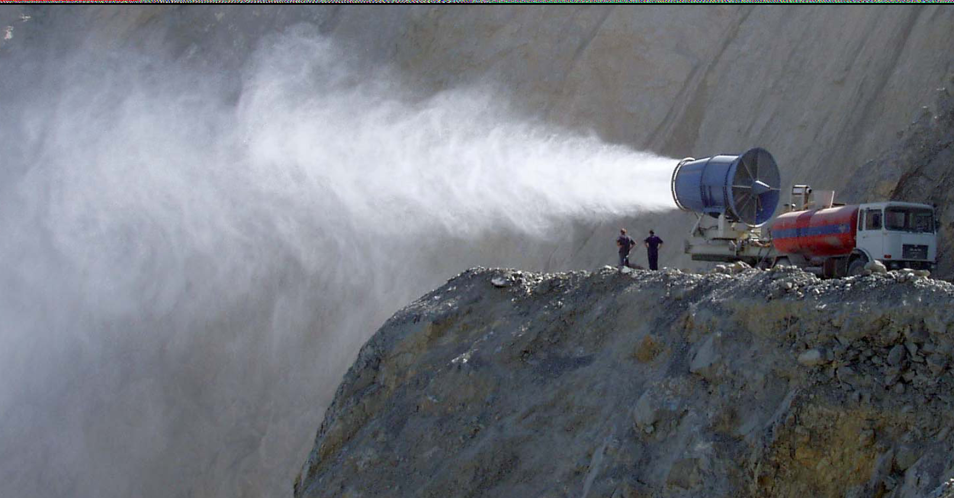
Fig.1. Fog cannon [14-15]

2. FAN DESIGN REQUIREMENTS; UTILIZATION OF THE CVD CONCEPT
In order to establish a fog cannon offering potential for competitiveness in the market, the following requirements have been formulated for the fan.
- The throw of a jet produced by a jet fan is defined as the distance at which the peak jet velocity (i.e. in the jet axis) has fallen to v_{p} = 0.5 m/s [2]. Throw of at least 40 m is to be achieved. The averaged outlet axial velocity necessary to achieve such throw, serving as design input, has been determined on the basis on empirics related to free jets.
- The air volume flow rate is to be within the range of 25 000 to 30 000 m³/h. The design flow rate has been set to q = 28 800 m³/h, corresponding to 8.0 m³/s.
- The above performance should be achieved with a driving electric motor of not more than P = 5.5 kW shaft power (asynchronous motor of 1440 RPM), with a fan of 710 mm outer diameter. These constrains enable the realization of a portable fog cannon of relatively light weight and moderate size (servable by a single person), and of limited costs to be spent on the motor and on the manufacturing process. Given that no static pressure rise is expected from the jet fan, i.e. Δp_{st} = 0 (it sucks from and also blows into the free atmosphere), the aimed total pressure rise was considered as the dynamic pressure of the produced jet. Based on the above data, the global design performance parameters have been set to Φ = 0.60 and Ψ = 0.43. These data indicate a relatively high specific performance, making the use of CVD reasonable (as for the fans in [3-4]).
- The blade count is to be possibly moderate, for moderation of costs. The rotor blade count has been chosen to 8. In order to produce a swirl-free, coherent axial jet, outlet guide vanes (OGV) have also been designed for elimination of rotor outlet swirl. The OGV blade count has been chosen to 9. The OGV blades serve also as supporting struts for the motor. Besides matching the Φ and Ψ design data, CVD offered herein a means also for moderation of blade count, as already noted in the Introduction.
- The blades are to be of simple geometry – possibly constant chord length along the span, moderate twist – for moderation of expenses in manufacturing. This requirement made use of the CVD concept again, as in the case of rotors in [3-4, 9]. The prototype rotor and OGV blades have been simply manufactured from sheet metal (cambered plate blades), having the leading and trailing edges rounded.
In what follows, further design considerations are listed. The reader is referred to [3, 5-6, 16-17] from the perspective of design as well as the analysis of spanwise change of flow features.
- A swirl-free rotor inlet at spanwise constant axial velocity has been assumed.
- The OGV was designed to fully eliminate the swirl in the outcoming jet.
- The radial velocity component has been neglected (cylindrical stream tubes).
- The hydraulic efficiency was initially taken briefly constant along the span.
- Incompressible flow was considered.
- The hub-to-tip ratio has been set to ν = 0.57, on the basis of design empirics.
- The characteristics of the annulus boundary layers were considered in the final design.
- The spanwise distribution of rotor isentropic total pressure rise has been prescribed using the following power function, proven to be reliable in former studies [3-6, 16-17]:
$ψ\left(R\right)=ψ\left(ν\right)⋅{\left(\frac{R}{ν}\right)}^{n}$ (1)
Beside the formerly outlined benefits of CVD, an additional remark is given herein on the relationship of spanwise distribution of rotor isentropic total pressure rise – associated with rotor swirl –, and axial velocity. The Bernoulli equation, extended to hydraulic losses, has been applied between rotor inlet and outlet in the relative frame, and then the result has been transformed to the absolute system. The Bernoulli equation has also been applied between OGV inlet and outlet. The two Bernoulli equations have been combined. The Euler equation of turbomachinery was applied in the resultant equation for expression of the isentropic total pressure rise. The resultant equation has been derived with respect to the radius. Considering the formerly listed assumptions, the final result in dimensionless form is
$2ϕ\frac{dϕ}{\text{dR}}=η_{h}\frac{dψ}{\text{dR}}$ (2)
Eq. 2 serves as a preliminary design tool for systematic tuning of the outlet axial velocity distribution, on the basis of the CVD concept. Since dψ/dR > 0 according to the CVD concept (Eq. 1), Eq. 2 implies that dϕ/dR > 0, i.e. the outlet axial velocity tends to increase toward the circumference, thus matching the requirement formulated for a fog cannon fan in the Introduction. Eq. 2 is a basic equation also for obtainment of spanwise velocity distributions, to be used as input to design of blade cascade geometry. Here, the following integral conditions are to be utilized. The area-averaging of the axial velocity distribution in the annulus must correspond to Φ, and the mass-averaging of the isentropic total pressure rise distribution in the annulus must correspond to Ψ.

3. PROTOTYPE FAN AND EXPERIMENTATION
The prototype fan has been manufactured by the Customer, and has experimentally been investigated at the premises of the Customer with involvement of the author. Figure 2 presents the photographs of the fan. The characteristic curve of the fan was measured in a “suction from surroundings – delivery to duct” configuration. The fan was attached to the inlet of a measurement duct. Δp_{st} was measured as the static overpressure downstream of the OGV in the annulus, relative to atmospheric. Far downstream of the fan, a standardized [18] through-flow orifice meter was installed in the duct, for volume flow rate measurement. The pressure differences were measured by certified Betz micromanometers. The rotor speed has been checked by a digital stroboscope. At the end of the duct, a throttle (baffle plate) has been installed, opening toward the atmosphere, for modification of fan operational points. Figure 3 shows the measured characteristic curve, corrected for nominal design conditions of 1.2 kg/m³ air density and 1440 RPM rotor speed. The symbols on the diagrams, representing the measurement points, correspond approximately to the experimental uncertainty. As the figure indicates, it was impossible to reproduce the design flow rate of 8 m³/s in this setup: even the highest flow rate, obtained at fully open throttle, is still below the design value. The reason is that, in absence of a booster fan, the aerodynamic loss developing within the facility (pressure drop along the duct and loss caused by the orifice meter) loads the fan even at fully open throttle. However, extrapolation from the descending section of the curve, obtained at the highest flow rates, matches fairly well with the design operational point, indicated with label D in the figure.

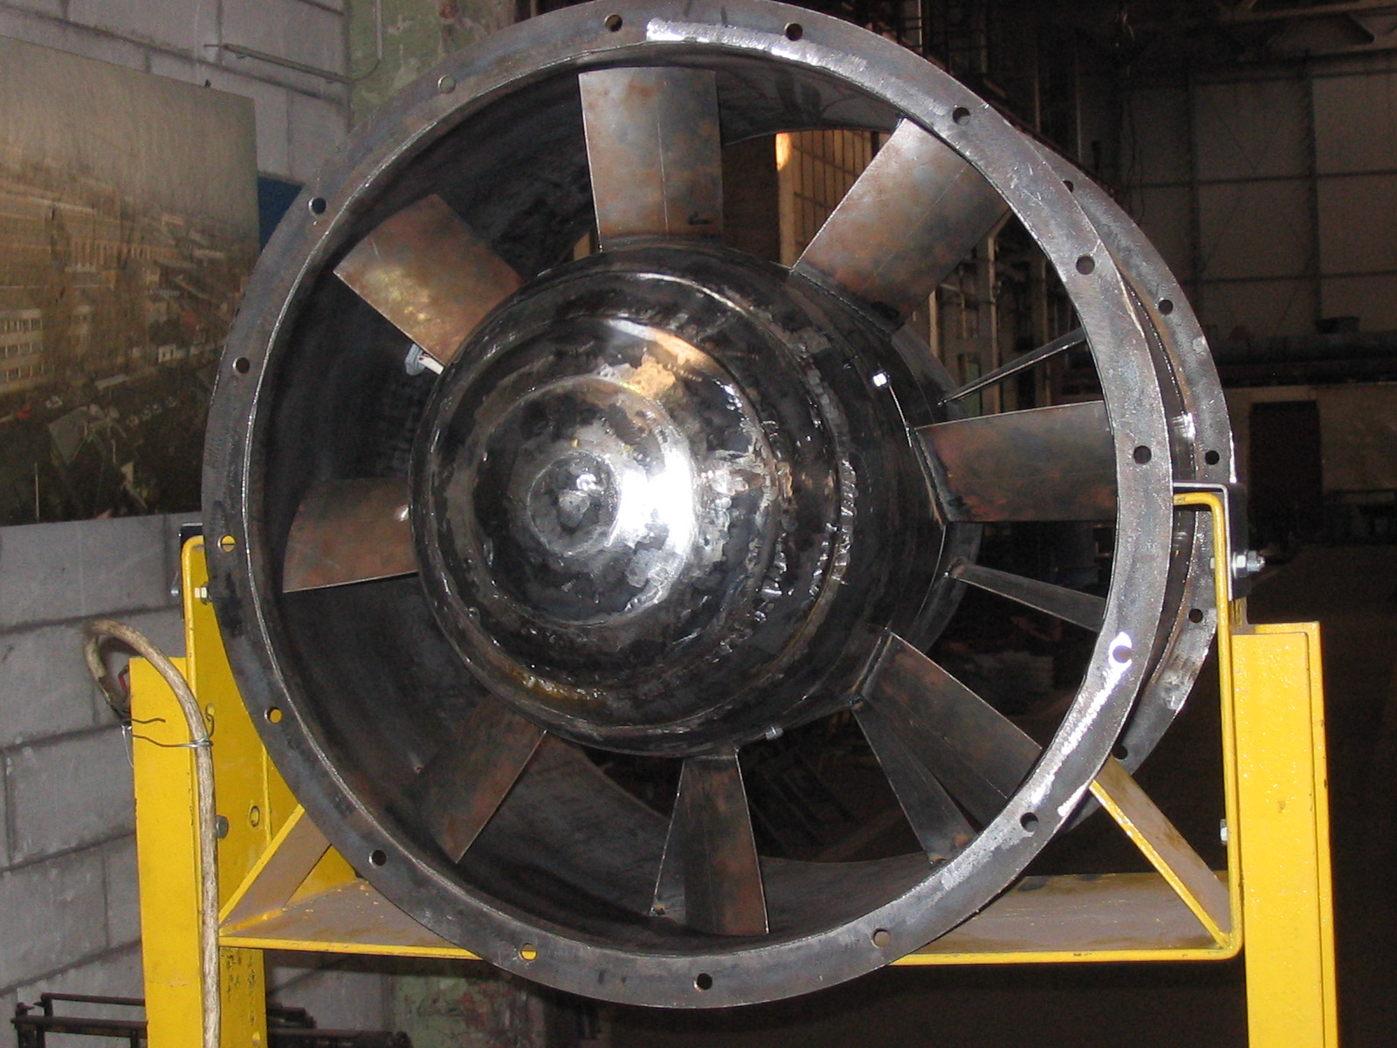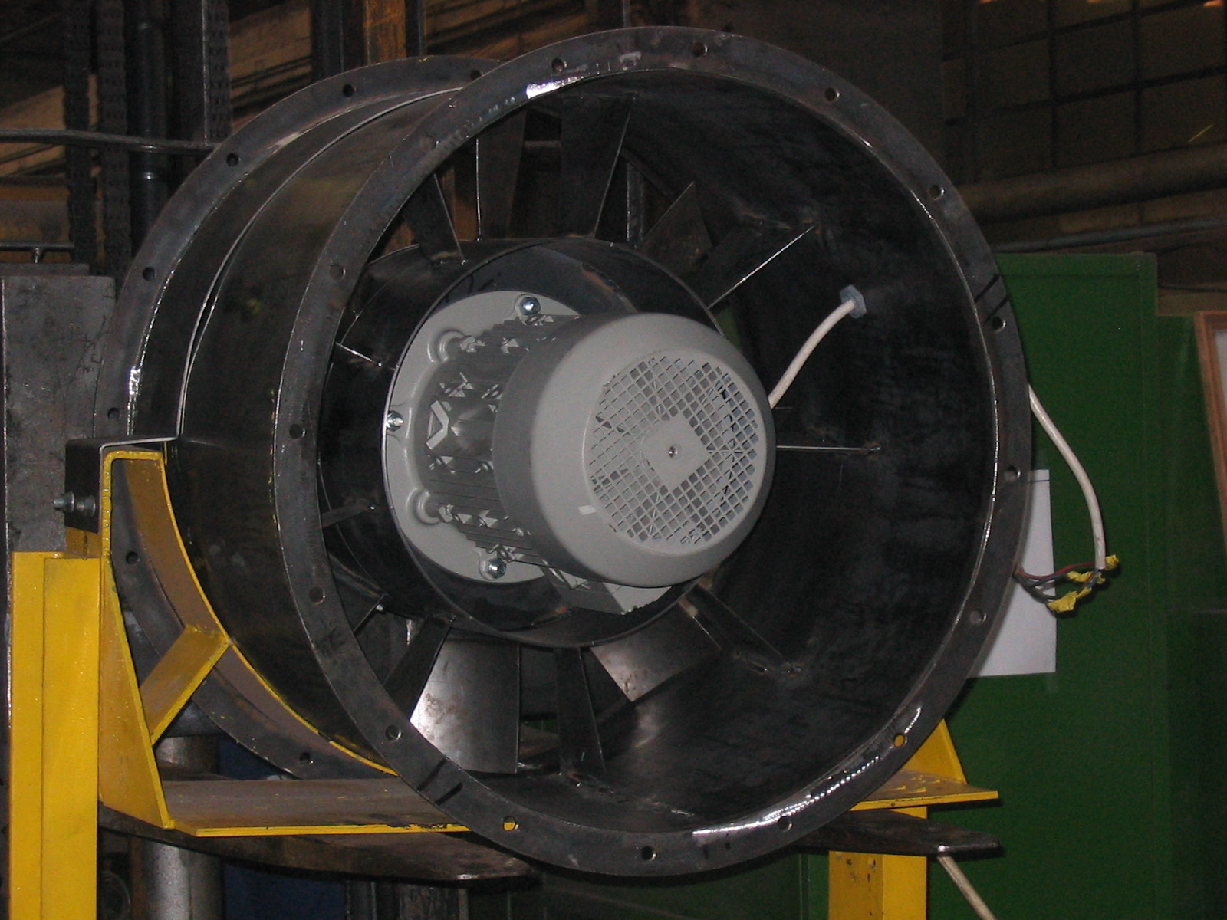
Fig.2. Prototype fan. Left: inlet view, right: outlet view

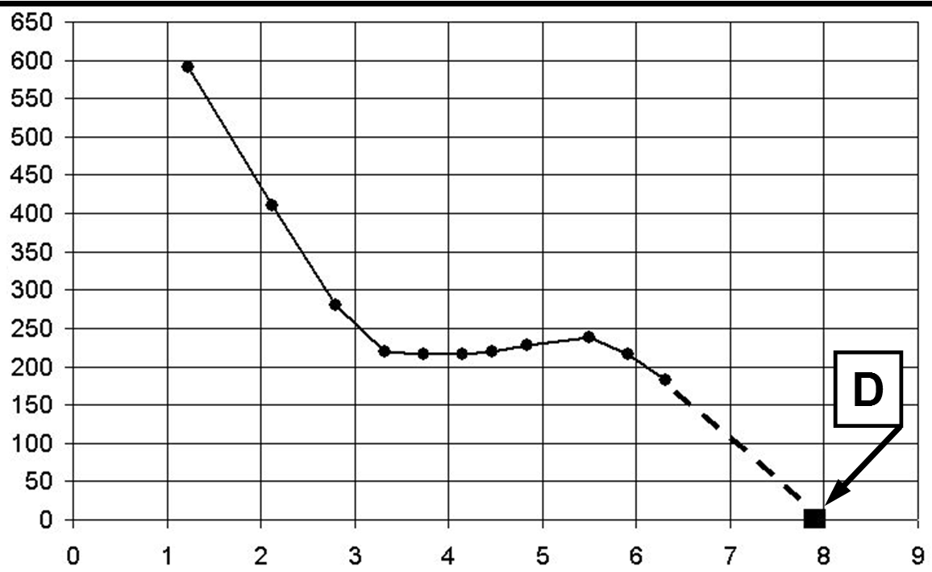
q
[m³/s]
Δp_{st}
[Pa]
Fig.3. Measured static characteristic curve

The electric power input to the driving motor has been measured as P_{el} = 6 400 W. The nominal operational data, related to the nominal motor shaft power of P = 5 500 W, are as follows (read from the motor data table): line voltage U = 400 V; input current I = 11.4 A; phase factor cos ϕ = 0.81. The nominal electric input current, calculated as
$P_{\text{el}}=\sqrt{3} U I \text{cos}ϕ$ (3)
just equals the measured P_{el} value, within the range of experimental uncertainty. This indicates that the motor operates at its nominal state: it is not overloaded (guarantee for long life cycle) but its available nominal shaft power of P = 5 500 W is fully utilised by the fan.
The jet fan operates according to its design goal at the state of Δp_{st} = 0. Based on Fig. 3, q = 8.0 m³/s is assumed for this state. In the outlet section of the annulus, this flow rate corresponds to an axial velocity of 29.9 m/s, and dynamic pressure of 540 Pa. Taking this dynamic pressure as the total pressure rise Δp_{t} performed by the fan, the total efficiency η_{t} of the fan blading is calculated as
$η_{t}=\frac{q {Δp}_{t}}{P}$ (4)
Substituting the relevant data, the efficiency has been estimated to η_{t} = 0.78. This efficiency is reasonably good for such blading of simple geometry.
It has been checked whether the OGV eliminates the outlet swirl indeed, providing a high-momentum, coherent axial jet. Figure 4 shows as the outlet flow direction is tested from tip to hub, using a wool tuft, contoured by a white line in the figure for better visibility. The figures confirm the appropriate operation of the OGV: the outlet mean flow is nearly axial.
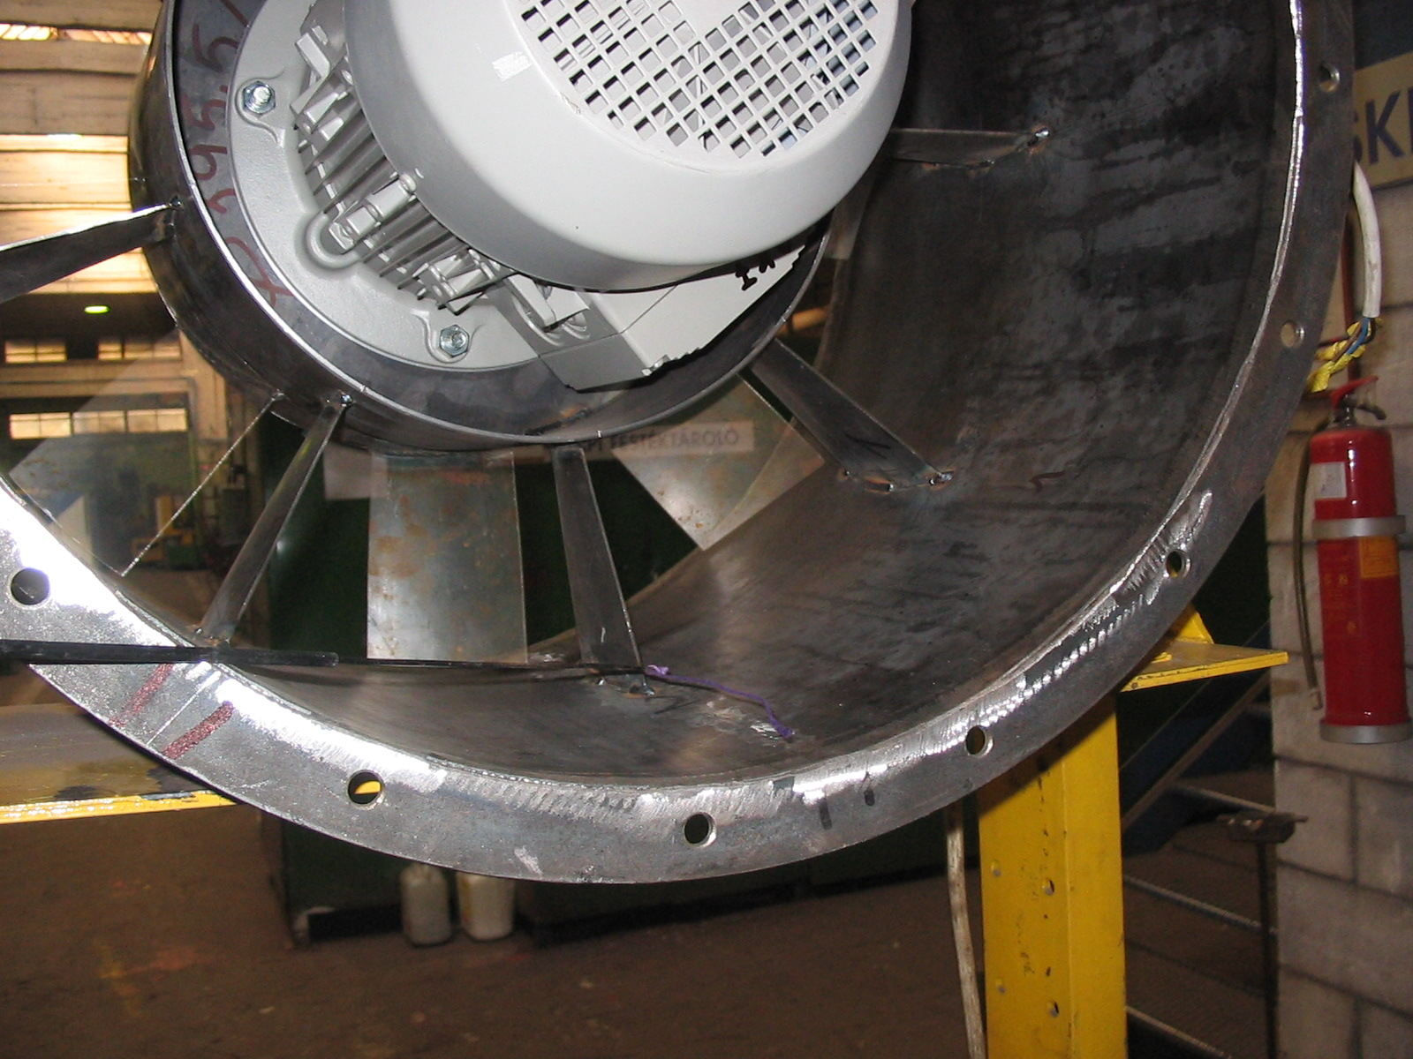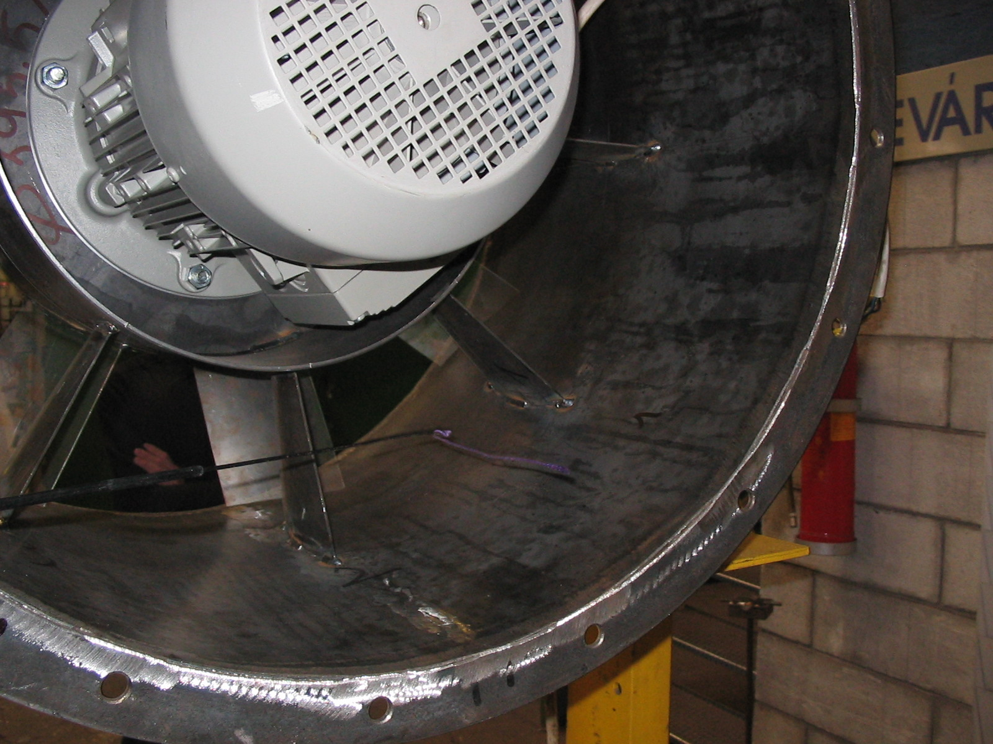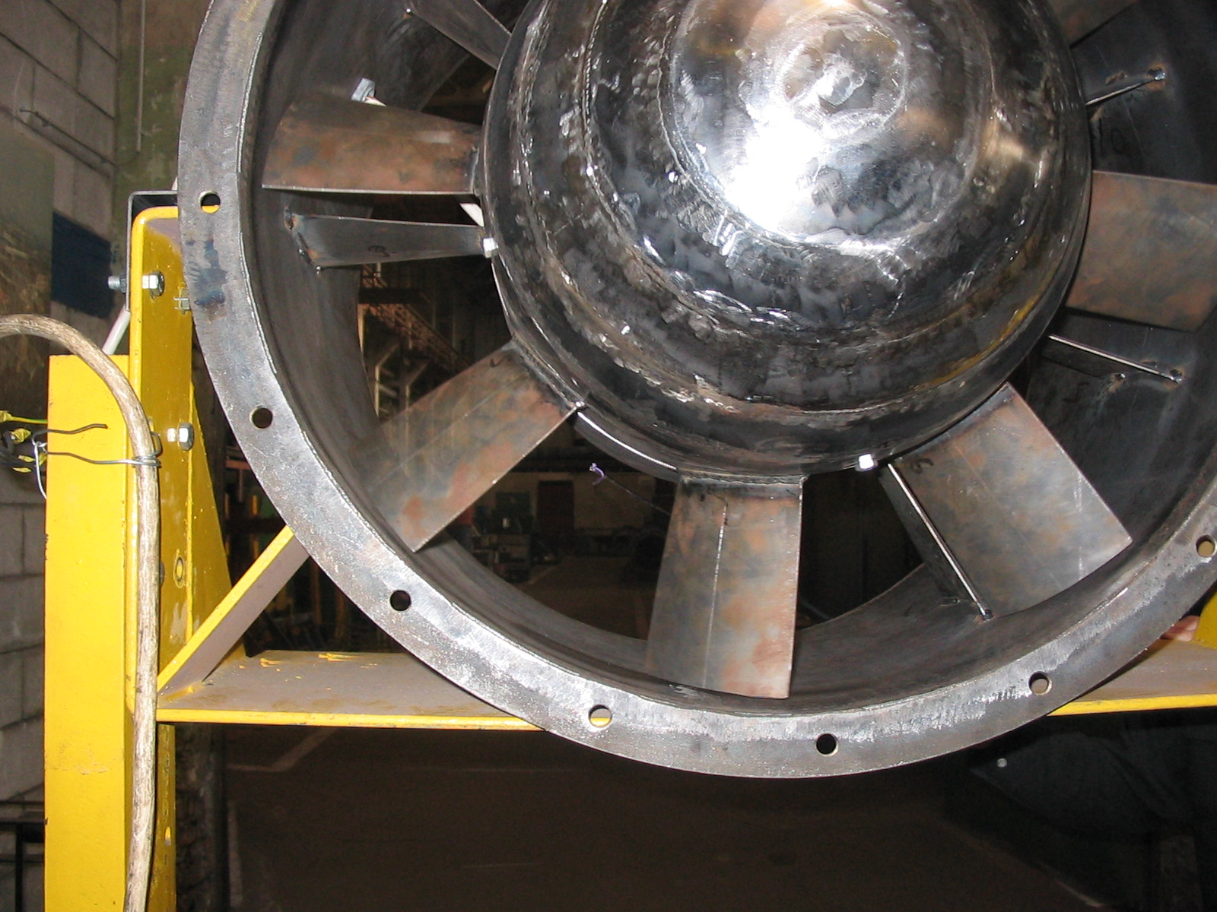
Fig.4. Snapshots on the outflow visualised using wool tuft. Left to right: from tip toward hub

The peak jet velocity v_{p} has been measured along the axis of fan rotation with use of a propeller meter (Mini-Air). The result is presented in Figure 5. As the figure shows, the throw – at which the peak jet velocity has fallen to v_{p} = 0.5 m/s – is approximately 45 m.
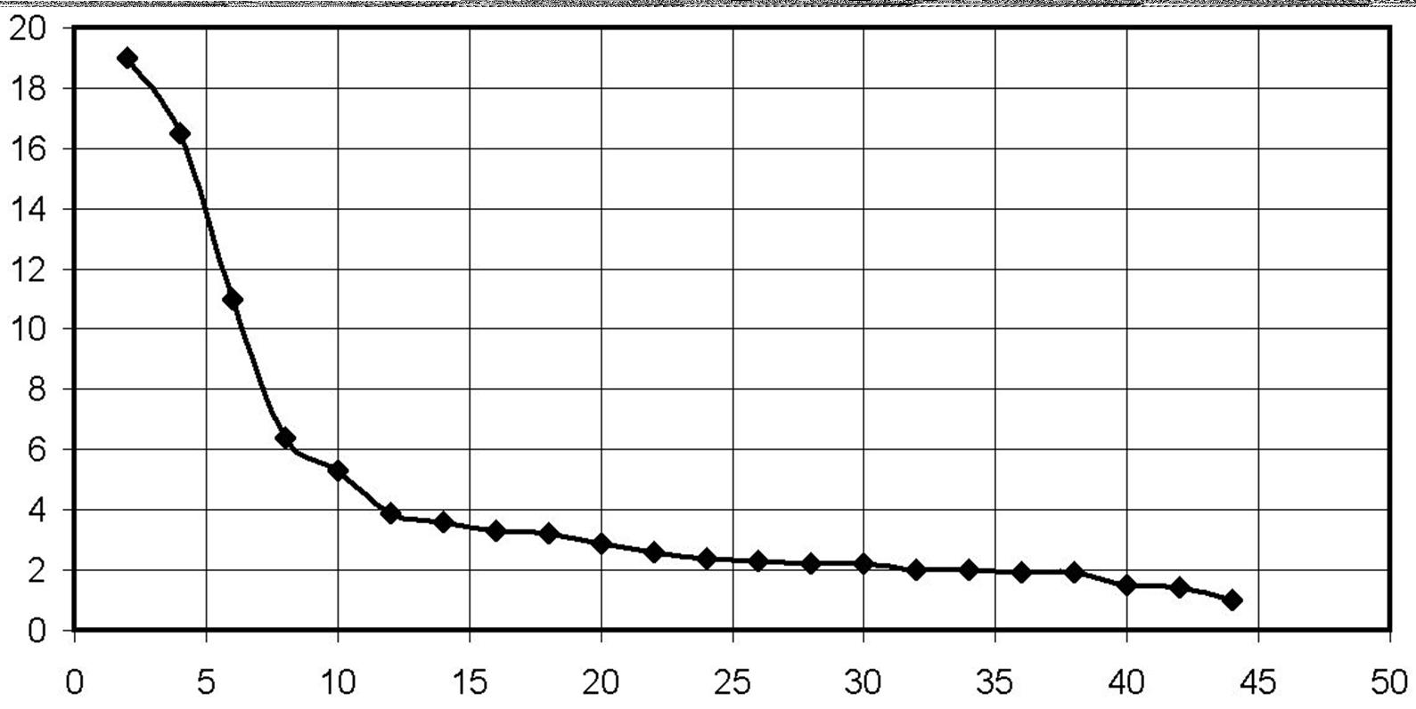
v_{p}
[m/s]
distance
[m]
Fig.5. Peak jet velocity measured along the fan axis

4. SUMMARY
An advanced application of the axial fan CVD technique has been outlined herein, for conceptual customization of the outlet axial velocity profile to the equipment served by the fan. This new potential related the CVD technique is to be systematically investigated in a future research programme, involving studies on the details of the flow field, by means of Computational Fluid Dynamics. The paper presents the design of a jet fan to be used in fog cannons, needing high axial velocity at higher radii, whereas moderate airflow at lower radii. Due to the thorough design procedure, the resultant fan shows the following beneficial features, confirmed by experimentation: throw over 40 m; delivery flow rate approximating 30 000 m³/h; moderate size of fan (∅ 710 mm) and motor (5 500 W), enabling portability and low production cost; high efficiency; moderate blade count and easy-to-manufacture blade geometry.
LIST OF SYMBOLS

cos ϕ phase factor

I input current

n power exponent in isentropic total pressure rise distribution along the span
Δp_{st} static pressure rise performed by the fan
P mechanical shaft power (input to the rotor)
P_{el} electric power input to the driving motor
q volume flow rate

R dimensionless radius: radius divided by rotor tip radius

U line voltage
v_{p} peak jet velocity
η_{h} rotor hydraulic efficiency: rotor real-to-isentropic total pressure rise
η_{t} fan total efficiency

ν hub-to-tip ratio
ϕ local flow coefficient: pitch-averaged axial velocity at the OGV outlet divided by rotor tip speed

Φ global flow coefficient: annulus area-averaged axial velocity divided by rotor tip speed
ψ local isentropic total pressure coefficient: rotor pitch-averaged isentropic total pressure rise divided by the dynamic pressure calculated with rotor tip speed
Ψ global isentropic total pressure coefficient: annulus mass-averaged isentropic total pressure rise divided by the dynamic pressure calculated with rotor tip speed

ACKNOWLEDGEMENTS
This work has been supported by the Hungarian National Fund for Science and Research under contract No. OTKA K63704. Gratitude is expressed to Szellőző Művek Kft. (VentilationWorks Ltd.) for permission to publish this paper.

REFERENCES

[1] | Gallimore, S. J., Bolger, J. J., Cumpsty, N. A., Taylor, M. J., Wright, P. I., Place, J. M. M. The use of sweep and dihedral in multistage axial flow compressor blading – Parts I and II. ASME J Turbomach 2002:124:521-541.
[2] | Daly, B. B. Woods practical guide to fan engineering. Woods of Colchester Ltd., 1992. (Sixth impression)
[3] | Vad, J., Bencze, F. Three-dimensional flow in axial flow fans of non-free vortex design. Int J Heat Fluid Flow 1998:19:601-607.
[4] | Corsini, A., Rispoli, F. Using sweep to extend the stall-free operational range in axial fan rotors. Proc Instn Mech Engrs, Part A, J Power Energy 2004:218:129-139.
[5] | Somlyódy, L. Axiális ventilátorok tervezése és jelleggörbeszámítása. (Design and characteristic curve calculation of axial flow fans) (in Hungarian) University Doctoral Dissertation, Technical University of Budapest, 1971.
[6] | Somlyódy, L. Wirkung der Drallverteilung auf die Kenngrössen von Axialventilatoren. Periodica Polytechnica, 1971:15:3:293-305.
[7] | Somlyódy, L. Improvement of the efficiency of free blow-out axial fans using variable circulation. Acta Technica Academiae Scientiarum Hungaricae 1974:79:115-132.
[8] | Meixner, H. U. Vergleichende LDA-Messungen an ungesichelten und gesichelten Axialventilatoren. Doctoral Dissertation, Universität Karlsruhe. Düsseldorf: VDI-Verlag 1995. Reihe 7: Strömungstechnik, No. 266.
[9] | Lakshminarayana, B. Fluid Dynamics and Heat Transfer of Turbomachinery. New York: John Wiley & Sons, Inc. 1996.
[10] | Jiang, Cai-ling, Chen Jiang-ping, Chen Zhi-jiu, Tian Jie, Ou Yang Hua, Du Zhao-hui. Experimental and numerical study on aeroacoustic sound of axial flow fan in room air conditioner. Applied Acoustics 2007:68:458-472.
[11] | Keszthelyi, I. Axiális ventilátorok tervezése a radiális sebesség-összetevő figyelembevételével. Mezőgazdasági axiális ventilátorok. (Design of axial fans with consideration of radial velocity component. Agricultural axial fans.) (in Hungarian) Magyar Épületgépészet 2000:49:11:27-28.
[12] | Gifford, N. L., Savory, E., Martinuzzi, R. J. Experimental study of automotive cooling fan aerodynamics. SAE Paper 2007-01-1525.
[13] | Noda, S., Mizuno, S., Suzuki, K. Fan noise and resonance frequency analysis in fan-cooled induction motor. Proc. VSTech 2005, The First International Symposium on Advanced Technology of Vibration and Sound, 2005, Hiroshima, Japan, 41-46.
[14] | www.fogcannon.com
[15] | Bruschi, P. Percorso virtuoso. Costruzioni 2009 Oct:22:26.  Available also at www.fogcannon.com
[16] | Vad, J. Laser Doppler anemometer investigation on the velocity field downstream of axial flow fans. Ph.D. Dissertation, Technical University of Budapest, Department of Fluid Mechanics, 1997. (in Hungarian)
[17] | Vad, J. Incorporation of forward blade sweep in the non-free vortex design method of axial flow turbomachinery rotors. Periodica Polytechnica, Mechanical Engineering Series, 2001:45/2:217-237.
[18] | ISO 5167-1:2003; ISO 5167-2 :2003. Measurement of fluid flow by means of pressure differential devices inserted in circular cross-section conduits running full.

