Models for simulation of lifecycle of filter mats
Tamás Lajos
Department of Fluid Mechanics
Budapest University of Technology and Economics
Keywords: filtration, dust, clogging, numerical simulation, flow field, inhomogeneity
Abstract
The most important parameters of fibrous filters, the separation efficiency and pressure drop, change during the period of operation. Theoretical and experimental investigations have been carried out to describe these processes and to develop an adequate model for numerical simulation of the clogging of filter mats. The model and some results of numerical simulations are presented in this paper. Also, basic considerations on the combination of the particle deposition on fibres inside the filter and the formation of dust cake are suggested.

1. Introduction
Fibrous filter mats play a significant part in the separation of solid particles and drops suspended in gas. Their wide application in air pollution control and in different technologies is justified by their reliability of service and relatively low overall cost. The porous layers are produced either as woven fabrics or felts. The most significant disadvantage of filters is the time dependence of their operation parameters. The temporal change is a consequence of the way of separation of particles in filters: the particles deposit on fibres, increasing in this way both the filtration efficiency and the pressure drop (at constant flow rate). This characteristic makes the design and in some cases also the operation of filters difficult. The objective of the research presented here has been to investigate the mechanism of particle deposition with special emphasis on the effect of previously separated particles and the inhomogeneity of filter structure. In addition, the research also aimed at developing a model to simulate the clogging process of fibrous filters.

2. Dust separation by filter mats
Industrial gases of usual concentrations, cleaned by fibrous filters, are very thin mixtures of solid particles and gas. Even in cases of relatively high concentration, c =10 g/m³, the average distance between particles is about 50 particle diameters which is in most cases in the range 10^{–1}< d_{p}[μm] < 10. Fibrous filters consist of cylindrical fibres of d_{f} = 5-30 μm diameter, the average distance between fibres is about 2-10 fibre diameters. Since the distance between fibres is in general much greater than the particle diameter, the particles should be displaced relative to gas in order to put them in contact with the fibres. This transport can be caused by inertia of particles, by gravity and, for smaller particles, by diffusion. In the case of charged particles and/or fibres electrostatic attraction also plays a role. Particles can also contact the fibres without displacement if they are moving along streamlines approaching the surface of the fibres of at most one particle radius distance (interception). The displacement of particles is hindered by viscous forces arising when particles are moving relative to the gas.
The influence of the deposited particle on the separation of subsequent particles and on the pressure drop was investigated and described by [1] – [3], but because of the ignoring of significant influencing factors the results obtained are only qualitatively correct. Deposited particles form on certain condition dendrites, which act as thin fibres influencing both the filtration efficiency and the pressure drop [3], [4], [5]. The description of the very complicated processes of particle deposition has been simplified by using the isolated fibre approach. In [3], [5], [6] the effect of dust load on the filter has been considered by modification of single fibre efficiency. Most of the authors suggested a linear relationship between the concentration of deposited particles and the increase of filtration efficiency:
${η_{l}}/{η_{f}}=1+{λc}_{d}$, (1)
where η_{l} and η_{f} are the single fibre efficiencies of loaded and clean fibres, respectively, c_{d} [kg/m³] is the concentration of deposited particles, λ is a factor depending mainly on the characteristics of the fibres, the particles and the filter load. The value of the single fibre efficiency expresses the ratio of the number of particles deposited on a given fibre to that of approaching the fibre in a layer of thickness equal to the fibre diameter d_{f}.
As a result of the first phase of the research reported here, the author suggested a method for calculation of a 3D flow field in inhomogeneous filter mats [7], and a simplified 1D model for describing the clogging process of filters [8]. Subsequently, a 3D model for calculation of dust deposition in realistic filter mats was published by Schweers and Lőffler [9] but no particle deposition has been considered. In the second phase of our research, the 3D calculation of flow in inhomogeneous filter mats and the extended dust deposition model have been combined [10], [11].
At high dust load, first a continuous layer of dust particles develops on the inlet of the filter mat, followed later by a dust cake . A model and a numerical simulation have been developed (Schmidt and Löffler [12]) to predict the process of this cake formation. More recently, measurement results were published by Rembor and Kasper [14] on the size of dendrites formed by deposited particles. On the basis of these results, the development of a comprehensive model combining the dust deposition inside the filter mat and, in the second period of the lifecycle of the filter, the formation of dust cake seems to be realistic.

3. Model for dust deposition inside the filter mat
Because of the complexity of flow in real filter mats due to complex fibre structure and because of the large number of dust particles (in case of d_{p} = 3 μm particle size and 10 g/m³ concentration, the number of particles in 1 cm³ gas is 3.5·10⁵), direct simulation of the dust separation process still seems to be impossible. That is why simplified models have to be developed relying on the basic laws of fluid mechanics as well as on some simplified assumptions drawn from experimental investigations. So, since the dominant position of the fibres is parallel to the surface of the mat and the dominant direction of filtration velocity is perpendicular to it, the fibres are supposed to be perpendicular to filtration velocity. From the point of view of the flow field the individual fibres are disregarded: the filter mat is considered as a porous layer of spatially and temporally changing permeability. The model for calculating the clogging process can be divided into two interconnected parts: simulation of particle deposition and calculation of the flow field in filter mat.

3.1. Simulation of particle deposition in filter mat
As a result of considerable efforts made in this field, a number of expressions have been published for calculation of the collection efficiency of clean single fibres. The expressions proposed in [9] have been used to calculate the single fibre efficiency in case of no dust deposition. The model described here is elaborated for monodisperse (d_{p} = const.) dust particles.
The model suggested by the author takes the effect of collected particles into consideration in the following way. The deposited particles increase the collecting surface of the filter mat and so they take part in the collection of subsequent particles. However, not all the surface area can be regarded as additional collecting area, because the particles and fibres "shadow" each other (see Fig. 1). This effect is considered by the shadowing factor k ≈ 0.5. Simple geometrical considerations show that only about half of the surface area of deposited particles (which are regarded as spheres) increases the collecting area of the filter mat.
Fig. 1: Shadowing effect
On the basis of experimental observations, two different models of particle deposition and their combination can distinguished. In the case of low filter loading, at the beginning of the filtration process, the majority of deposited particles cover the surface of the fibres. The effect of the deposited particles can be taken into consideration as an increase of fibre diameter: thickening model, see Fig. 2.
At higher filter loading, the ratio of particles collected by formerly deposited particles increases, so more and more dendrites will be formed: this is the dendrite model. During the filtration process the combination of these two models occurs, called the combined model (Fig. 2).
Fig. 2: Deposition models
Since the particles depositing according to the thickening model and the dendrite model influence the separation and pressure drop quite differently, the shear factor b is suggested expressing the ratio of the amount of particles forming dendrites to the amount of all deposited particles. On the basis of evaluation of experimental results of several authors and own measurements, a linear correlation has been found between the share factor and the concentration of particles collected previously:
b = 0.024 c_{d.} (2)
The efficiency (E) of filter layer of Δx width (η_{m}) can be expressed:
$E=1−\frac{c_{o}}{c_{i}}=1−\text{exp}(−\frac{a_{f} η_{l}}{π}Δx)$, (3)
where c_{o} and c_{i} [kg/m³] is dust concentration at the outlet and inlet of filter layer, respectively and a_{f} [m²/m³] is the specific collecting area of fibres in filter layer.
In Eq.(3) the single fibre efficiency of loaded filter η_{l} includes the effect of collected particles. According to the model assumptions suggested it can be expressed in the following way [11]:
$η_{l}=η_{f}\left[1+\frac{c_{d}}{ρ_{p} d_{p} a_{f}}\left(3(1−b)+4b(\frac{η_{\text{dend}}}{η_{f}}−k)\right)\right]$, (4)
where ρ_{p} [kg/m³]is the density of dust particle and η_{dend} is the single fibre efficiency of the dendrites.
The comparison of Eq.(4) and Eq.(1) with experimental results show that Eq.(4) based on model considerations describes much more accurately the influence of deposited particles on particle collection than Eq.(1) suggested previously [9].

3.2. Calculation of 3D flow field in filter mats.
Because of the small size of particles and fibres and the relatively low filtration velocity, the particle and fibre Reynolds numbers are small, so the flow in porous filter mats is laminar. The pressure drop Δp [Pa] across the filter mat, needed to reach a given filtration velocity v_{f} [m/s] through the filter mat can be determined as the aerodynamic force acting on fibres in filter mat of 1m² area:
$Δp=\frac{4π}{\text{Ku}}μ L v_{f}$, (5)
where μ[kg/m/s] is the dynamic viscosity, Ku is the Kuwabara coefficient [13]
$\text{Ku}=−0\text{.}5 \text{ln}α−0\text{.}\text{75}+α−0\text{.}\text{25}α^{2}$, (6)
depending on the packing density α = V_{f}/V_{m} of the filter mat (V_{f} and V_{m} is the volume of fibres and filter mat, respectively), s [m] thickness of the mat and L[m] the overall length of fibres in filter layer of 1m² area:
$L=4 α s/{\left(d_{f}^{2}π\right)}$. (7)
Inserting Eq. (7) in Eq. (6) and substituting the thickness of the layer s [m] by Δx (x co-ordinate is perpendicular to the surface of the filter mat and pointing in the direction of the flow) and considering that the gas is flowing in the direction of pressure decrease, the x component of the filtration velocity can be expressed:
$v_{\text{fx}}=−\frac{\text{Ku} d_{f}^{2}}{4π μ α}\frac{Δp}{Δx}$ (8)
Eq. (8) shows that by neglecting the inertia of fluid and particles with respect to viscous and pressure forces the generalised form of Darcy equation can be formulated:
$\underline{v}=− C \text{grad} p$, (9)
where C [m³s/kg ] is the permeability coefficient which can be expressed in the case of loaded filters as
$C=\frac{\text{Ku}}{\text{16} μ}\frac{1}{\frac{α}{d_{f}^{2}}+\frac{b c_{d}}{ρ_{p} d_{p}^{2}}}$. (10)
Eq. (10) takes both the thickened fibres and the dendrites into consideration.
By neglecting the volume of fibres and particles and the compressibility of gas, the continuity equation (div v = 0) can be transformed using Eq. (9):
div (C grad p) = 0 (11)
Knowing the actual 3D permeability distribution in filter mat and the boundary conditions: x = 0 p = p_{in}, x = h p = p_{in} – Δp_{f}, on the periphery $∂p/∂y=0, ∂p/∂z=0$ (see Fig. 3) the flow field can be calculated.
Fig. 3: Co-ordinate system and division of filter mat.

3.3. Simulation of particle collection process
The filter mat is divided into a number of elements (Fig. 3) and the initial characteristics of the elements (packing density and fibre diameter) are given. Also, the particle diameter, inlet dust concentration, pressure drop across the mat (or filtration velocity), gas viscosity and particle density should be known. After calculating the permeability coefficient by using Eq. (10), the pressure distribution can be determined by solving Eq. (11). The inlet and outlet velocities at all faces of the volume elements can be determined from the p distribution. Also, the single fibre efficiency for clean fibres, and by using Eq. (4) that for loaded fibres, can be calculated for all filter elements. By using these variables and the dust concentration at the inlet of the filter mat, a mass balance equation can be formulated for each filter element: the difference between the particle mass entering and leaving the filter element in a given time interval Δt [s] is equal to the increase in the quantity of collected particles. Summarising the mass of collected particles, the filtration efficiency of the filter mat (E) can be calculated. At the end of the prescribed time interval the collected mass of dust and by using Eq. (10) a new distribution of permeability coefficient can be determined, so the next cycle of calculation for the next time interval can be started.

4. Considerations on the formation of dust cake
The lifecycle of a filter mat can be divided into two parts: the period of filtration by the fibres and already deposited particles situated in the depth of the filter mat. Since the particle concentration is highest at the inlet of the filter mat, and the deposition of particles enhances subsequent collection, the concentration of the deposited particles increases at the inlet very rapidly. This can be seen in Fig. 4 showing the result of a 1D calculation of the distribution of deposited particle concentration (c_{d}) across the filter mats at four different dust loads.
If the dendrites created by the deposited particles near the inlet of the filter mat bridge the distance between fibres, the second period of the lifecycle of filter mat starts. A continuous and gradually thickening dust layer (dust cake) arises, assuming the task of collection of subsequent particles. The regular removal of individual dust particles from the surface of the fibres situated inside of the mat is practically impossible because of the very strong attraction forces, i.e. the filter mat can not be cleaned or regenerated. In case of formation of dust cake on the inlet surface of filter mat the bulk of separated dust can be removed relatively easily by shaking the filter bags or by using reverse flow. Those filter mats, where the collection on the surface dominates, can be regenerated periodically, so they are widely used for cleaning gases of relatively high dust concentration.

Fig. 4: Variation in concentration of deposited particles across filter mats
The final objective of the research presented here is the combination of the simulation of the filtration processes in both periods of the lifecycle of filter mat. The simulation of the first filtration period is outlined in this paper and methods for calculation of the development of dust cake are also available [12]. The combination of the two simulation methods necessitates the correct description of the formation of the initial continuous dust layer. Recent experimental investigations on the lateral size of dendrites developing on the surface of fibres [14] resulted in a quite contradictory statement: the lateral size of the bundle of dendrites is much smaller than the average distance between fibres. Consequently, if the fibres are homogeneously distributed the formation of a continuous dust layer can arise only at a very high concentration of deposited particles.
The author suggests that the formation of dust cake at relatively low dust loads is explained by the inhomogeneity of fibre distribution. In this case first the relatively small distances between part of the fibres will be bridged and so "fibres" of much higher diameter occur. The dendrites developing on these thicker formations can bridge much larger distances.

5. Results of simulation
3D numerical simulation of the flow field has been performed for filter mats of different inhomogeneity of fibre packing density. The model filters have been put together from filter elements selected randomly from a set of filter elements the permeability coefficient of which corresponded to the Gaussian normal distribution of given standard deviation. The calculated increase in the overall permeability of the filter mat with increasing inhomogeneity has shown good agreement with experimental results [7].
The results of numerical simulation of the clogging process show acceptable agreement with results published in the literature. Fig.5 shows the calculated and measured change of pressure drop and filtration efficiency of filter mat as a function of specific dust loading (which is proportional to the filtration time).
Fig. 5: Change of filtration characteristics as function of dust load
The dust deposition decreases the inhomogeneity of overall packing density in the y and z directions and increases in the x direction (Fig. 3). The rate of decrease of inhomogeneity in the y – z planes depends also on the amount of collected particles: it is quite considerable close to the inlet and much less at the outlet. This is clearly demonstrated by the calculated velocity distributions at inlet and outlet of gradually loaded filter mats shown by Fig.6. At the inlet of the mat, the concentration of the deposited
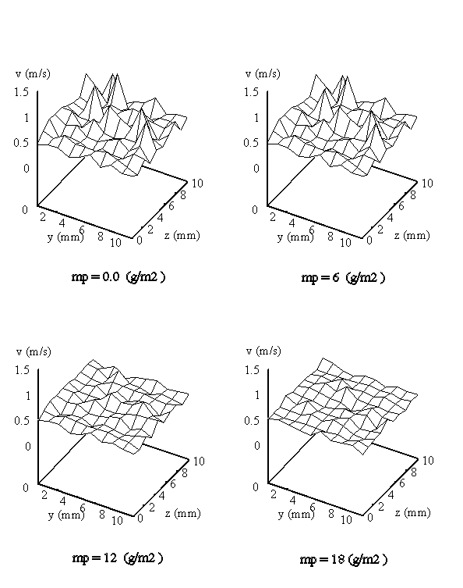
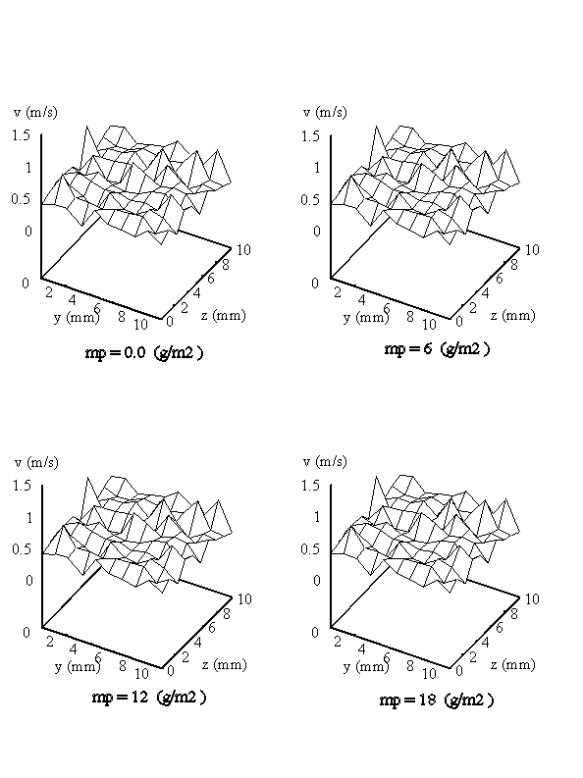

- b)

Fig.6: Calculated velocity distributions at inlet and outlet of clean
and loaded filter mats
particles increases very considerably during the clogging process, so the velocity distribution becomes more and more uniform. In contrast, at the outlet, where the concentration of the suspended (and, therefore, that of the deposited) particles is relatively small, the change of the velocity distribution is moderate.

6. Conclusions
A model of dust deposition relying on experimental investigations has been developed. The model regards a part of the surface of the deposited particles as an additional collecting surface. The shadowing effect and the share factor have been suggested to simulate the real processes more accurately. A numerical method has been developed for calculation of 3D flow field in filter mat based on a generalised form of the Darcy equation and continuity equation. The results of the filtration process simulation show acceptable agreement with the experiments. The numerical simulation of combination of the two phases of lifecycle of a filter mat needs further investigation concerning formation of the continuous dust layer. Significant influence of inhomogeneity of fibre structure on the formation of initial continuous dust layer is suggested.

References
[1] Stenhouse, J.I.T. and Trottier,R. ”The Loading of Fibrous Filters with Submicron Particles ” J. Aerosol Sci. (1991), Vol. 22. pp. S777- S780.
[2] Yoshioka, N. et al. ” Filtration of Aerosols through Fibrous Packed Bed with Dust Loading ” Chem. Eng. Japan, 33 (1969), pp. 1013-1019.
[3] Kanaoka C., et al. "Simulation of the Growing Process of Particle Dendrite and Evaluation of a Single Fibre Collection Efficiency with Dust Load" J. Aerosol Sci. (1980) Vol. 11. pp. 377-389.
[4] W. Bergman et al. ”Enhanced Filtration” Lawrence Livermore Laboratory. (1976).
[5] Lastow O. ” Simulation of Dendrite Formations of Aerosol Particles on a Single Fibre ” J. Aerosol Sci. Vol. 25. (1994) pp. S199-S200.
[6] T. Myojo, et al. ”Experimental Observation of Collection Efficiency of a Dust-Loaded Fibre” J. Aerosol Sci. Vol. 15, (1984), pp. 483-489.
[7] Lajos T. ”The Effect of Inhomogeneity on the Flow in Fibrous Filters ” Staub Reinhaltung der Luft. Band 45, (1985), pp. 19-22.
[8] Lajos T. ”A Model for Calculation of Clogging Process in Filter Mats” 1. World Congress Particle Technology, Nürnberg (1986), pp.175-188.
[9] Schweers, E., and Lőffler F. ”Realistic Modelling of the Behaviour of Fibrous Filters through Consideration of Filter Structure” Powder Technology 80 (1994) pp. 191-206.
[10] Abd El-Hamied, A.A., Lajos, T.: "Investigation of loaded fibrous filter" Periodica Polytechnica Ser. Mech. Eng. Vol. 41. (1997) No.1. pp. 3-20.
[11] Abd El-Hamied, A.A.: "Investigation of the dust separation process in fibrous filters" Thesis, Technical University of Budapest, (1997).
[12] Schmidt, E., Löffler, F.: "Verification of Dust Cake Compression by Means of Structure Analysis and the Effect of Filtration Performance". 6th World Filtration Congress, Nagoya, Japan (1993) pp. 54-59.
[13] Kuwabara S. ”The Forces Experienced by Randomly Distributed Parallel Circular Cylinders or Spheres in Viscous Flow at Small Reynolds Numbers” J. Phys. Soc. Japan 4. (1959), pp. 527-532.
[14] Rembor H. J. and Kasper G.: "Transient Filtration Behaviour of Fibrous Filters: Deposited Particulate Structures Studied with a Confocal Laser Scanning Microscope" Proc. of the 1999 Fall Topical Conf. Minneapolis (1999) pp. 39-46.

Acknowledgement
Author acknowledges the support of National Research Fund OTKA (T023755).

Nomenclature
a [m²/m³] Specific collecting surface
A_{eff} [m²/m³] Effective collecting surface
b [-] Share factor
c [ kg/m³] Particle concentration
C [m³s/kg] Permeability coefficient
d [m] Diameter
E [-] Filter efficiency
F [N/m] Drag force per unit length
F* [-] Dimensionless drag
h [m] Filter thickness
k [-] Constant
L [m/m²] Fibre length per unit area
m_{p} [g/m²] Dust load
p [Pa] Pressure
t [s] Time
v [m/s] Velocity vector
v_{x,y,z} [m/s] Velocity component in x, y, z directions
Δx [m] Thickness of filter element
Δy [m] Width of control volume in y direction
Δz [m] Width of control volume in z direction
α [-] Packing density
μ [kg/m.s] Dynamic viscosity
ρ [ kg/m3] Density
η [-] Single fibre efficiency

Subscripts
d Deposited
den Dendrite
f Fibre, filtration
i Inlet condition
l Loaded condition
m Mean value
o Outlet condition
p Particle
th Thickening

